|  |
| --- |
|  |
| Capstone Project Document |

**Vietnamese Medicinal Plants Network**

Report #6 – Installation Guide

|  |  |  |
| --- | --- | --- |
| **Vietnamese Medicinal Plants Network** | | |
| **Group Members** | Nguyễn Minh Tiến | SE02545 |
| Trần Bình Khánh | SE02764 |
| Nguyễn Hải Đăng | SE02992 |
| Hoàng Thị Quỳnh | SE02639 |
| **Supervisor** | Mr. Nguyễn Văn Sang | |
| **Project code** | VMN | |

**- Hanoi, 04/2016 -**

# 

# SIGNATURE PAGE

AUTHOR: Nguyễn Minh Tiến 20/04/2016

Project manager

REVIEWERS: Nguyễn Hải Đăng 21/04/2016

Team member

APPROVAL: Nguyễn Văn Sang --/--/--16

Supervisor

Record of change

*A - Added M - Modified D – Deleted

|  |  |  |  |  |  |
| --- | --- | --- | --- | --- | --- |
| Effective Date | Changed Item | A,M,D | Change Description | Reason for Change | Rev. Number |
| 20/April/2016 | User installation | A | Add new |  | 1.0 |
|  |  |  |  |  |  |
|  |  |  |  |  |  |
|  |  |  |  |  |  |
|  |  |  |  |  |  |
|  |  |  |  |  |  |
|  |  |  |  |  |  |
|  |  |  |  |  |  |
|  |  |  |  |  |  |
|  |  |  |  |  |  |
|  |  |  |  |  |  |
|  |  |  |  |  |  |
|  |  |  |  |  |  |
|  |  |  |  |  |  |
|  |  |  |  |  |  |
|  |  |  |  |  |  |

Table Contents

SIGNATURE PAGE 1

1 INTRODUCTION 3

1.1 Purpose 3

1.2 Environment 3

2 Installation Guideline 3

# INTRODUCTION

## Purpose

This document contains guide lines step by step to deploy VMN website and This user's manual has been developed to help users better understand the requirements that may apply to use this website by providing them simple step by step tutorials. This manual is intended to help make website's functions more accessible and their associated requirements more understandable to users.

## Environment

Following are the software required to start the VMN system:

* Operating System: Ubuntu 14.04 LTS.
* Apache 2.2
* Browsers: Firefox 40, Chrome 44 or higher.
* Database: MySQL server.
* PHP 5.5.31 or 5.6.
* Composer (<https://getcomposer.org/>)
* Git for source checkout

# Installation Guideline

## Create Database

Sign in to mysql by command : $ mysql –uroot –proot;



Create database named “vmn” by command: $ create database vmn;



## Get source code for installing

Change current directory to /var/www by Using command: $ cd /var/www



Checkout source code from <https://github.com/tientoantai/vmn.git> to directory: “/var/www” by command:

$ git clone “<https://github.com/tientoantai/vmn.git>”

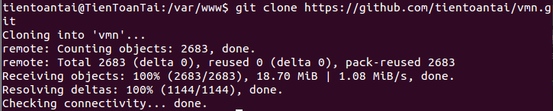

## Get project’s component by composer

Change current directory to project directory (using command: $ cd “project-directory-path”).



Run command: $ composer install



## Setup database structure and data sample

To setup database structure run command: $php artisan migrate



To initiate sample data using command: $ php artisan db:seed

